**SE305-Loukie’s catering Phase 1 Evaluation**

|  |  |  |  |
| --- | --- | --- | --- |
| **Project** **Title**: | | | **Team Number** : |
| **Items** | **Weight** | **Grade** | **Notes** |
| Abstract | 1 |  |  |
| Similar Systems | 2 |  |
| Problem Statement | 2 |  |
| System Scope and Context | 2 |  |
| User Stories | 3 |  |
| Functional Requirements | 5 |  |
| Non-functional Requirements | 5 |  |
| Data Design | 5 |  |
| Preliminary Object-Oriented Domain Analysis | 5 |  |
| Correct Citation | 5 |  |
| Project Plan and task distribution | 5 |  |
| **SRS Document** | **40** |  |
| All application forms with frontend validation | 10 |  |
| All Application frontend pages | 10 |  |
| CRUD operations for at least Two forms | 10 |  |
| Application UI/UX quality | 10 |  |
| **Project Implementation** | **40** |  |
| **Bonus** | | |
| Product Owner Feedback Form | 5 |  |
| Hosting the application on AWS | 5 |  |
| Accomplishments (Coursera Certificate) | 10 |  |
| **Project Total Grade** | **80** |  |

# **Team Individual Evaluation and Final Grade**

|  |  |  |  |  |  |
| --- | --- | --- | --- | --- | --- |
|  | **ID**  [Ordered] | **Full Name** | **Discussion (10)** | **GitHub**  **(10)** | **Total (100)** |
| **1** |  |  |  |  |  |
| **2** |  |  |  |  |  |
| **3** |  |  |  |  |  |
| **4** |  |  |  |  |  |

Assessor Name : Assessor Signature :

# **Project Information**

**Live Application URL (AWS):**

# Abstract

Write an abstract description of your project here (Max 150 words).

# Application Overview

Include System overview diagram, use case diagram and screen shots of the application main screens.

**Loukie owns a catering page on Facebook. She offers a huge variety of food and She can organize whole events’ buffet. The main problem is that the client isn’t able to communicate with all her customers properly due to only having a Facebook page.We have decided to engage this problem by designing a web application that is easy to manage for our client because of her main problem. We are developing a web application to help our client to manage her time and make the ordering process easier. Increase sales and be well-organized content, user-friendly site, effective calls to action, increase conversion rate.**

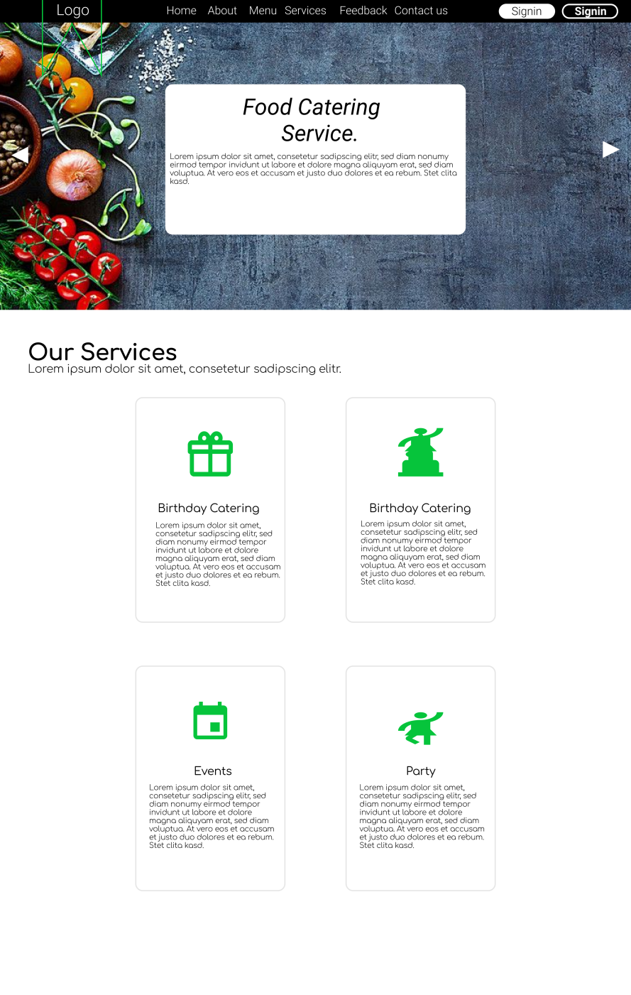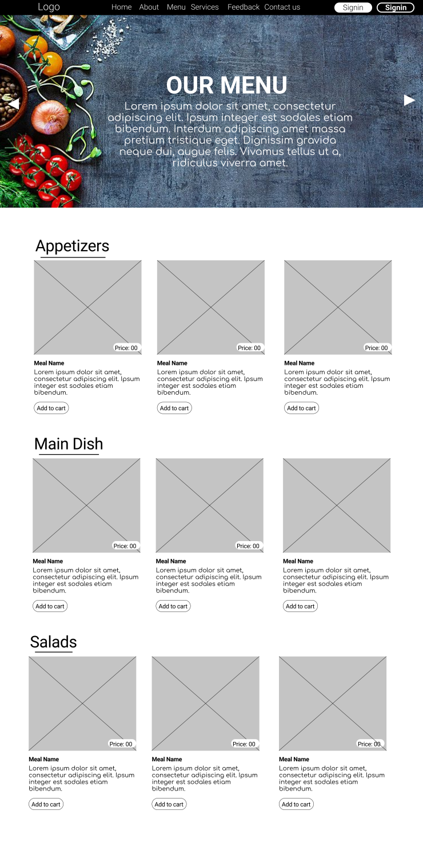

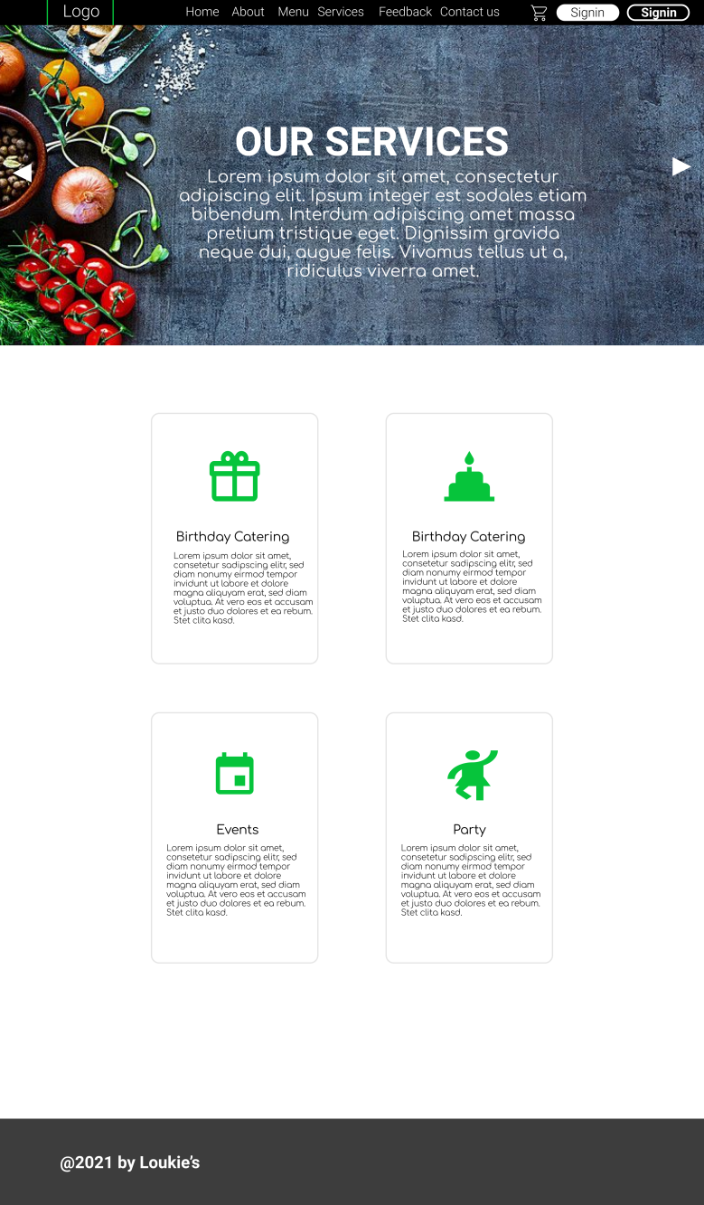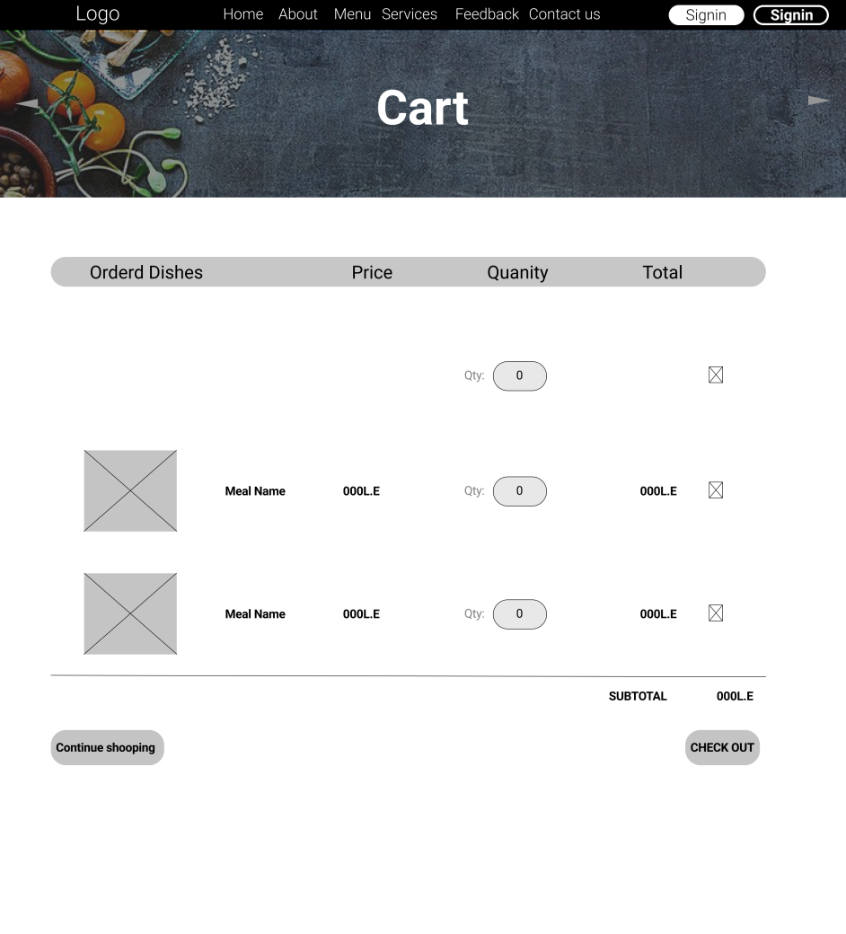

# GitHub repository

**GitHub URL: https://github.com/ahmedhesham-1/catering.git**

Include screenshots of your project GitHub repository and contributors’ insights showing each team member commits.

# Tasks distribution:

|  |  |  |  |  |  |
| --- | --- | --- | --- | --- | --- |
| ID | Task name | Description | Start date | Duration | Assigned team member |
| **1** |  |  |  |  |  |
| **2** |  |  |  |  |  |
| **3** |  |  |  |  |  |
| **4** |  |  |  |  |  |
| **5** |  |  |  |  |  |
| **6** |  |  |  |  |  |
| **7** |  |  |  |  |  |
| **8** |  |  |  |  |  |
| **9** |  |  |  |  |  |
| **10** |  |  |  |  |  |
| **11** |  |  |  |  |  |
| **12** |  |  |  |  |  |
| **13** |  |  |  |  |  |
| **14** |  |  |  |  |  |
| **15** |  |  |  |  |  |
| **16** |  |  |  |  |  |
| **17** |  |  |  |  |  |
| **18** |  |  |  |  |  |
| **19** |  |  |  |  |  |
| **20** |  |  |  |  |  |